Progress Update- HMP website
Name: Alex Gabrielle Marri Sequito
Role: Frontend Developer
Tools/Frameworks Used: ReactJS, TailwindCSS

Home Page:


- NavLink active styling verified and working correctly across routes.
- Button components include hover states and transition animations.
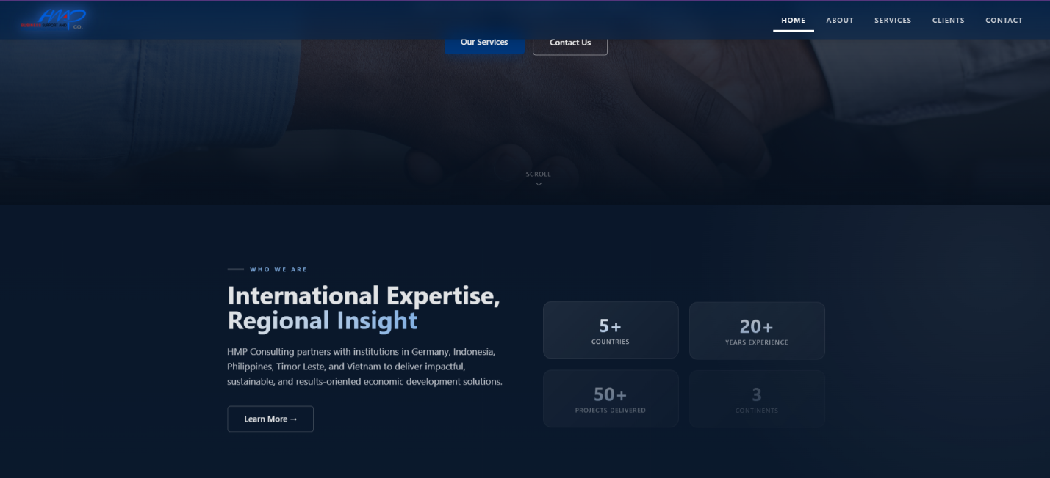
- Background image/hero uses parallax, so background image moves on scroll
- If home page is reloaded/landed on, section smoothly eases in page
- Navbar turns gradient from solid to transparent as users scroll further down onto the page
- HMP logo also zooms out when scrolling on other sections and is bigger when on the hero/start of the page
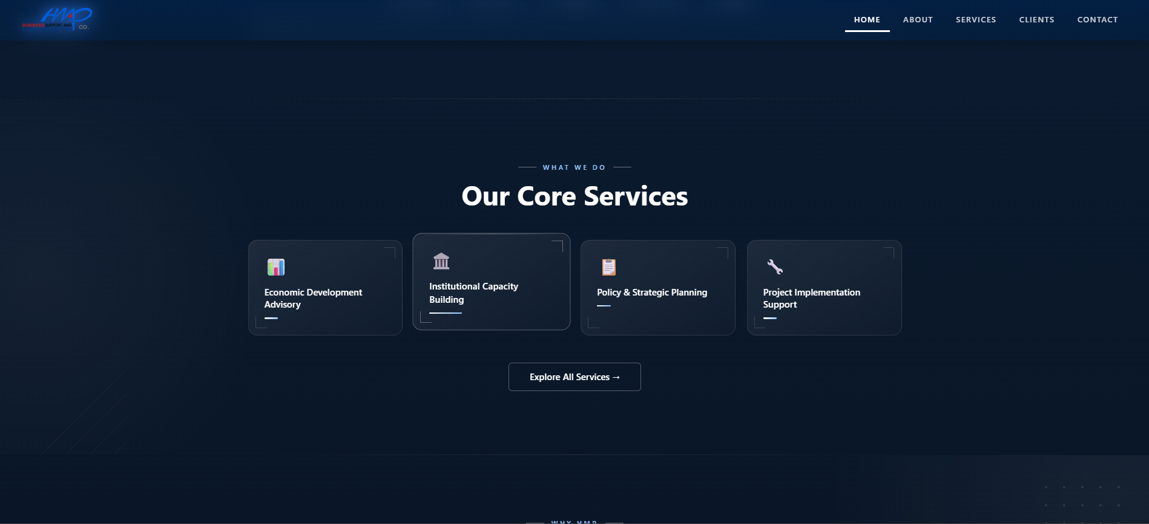
- Icon holders pop up on click/hover
- Buttons navigate to appropriate pages
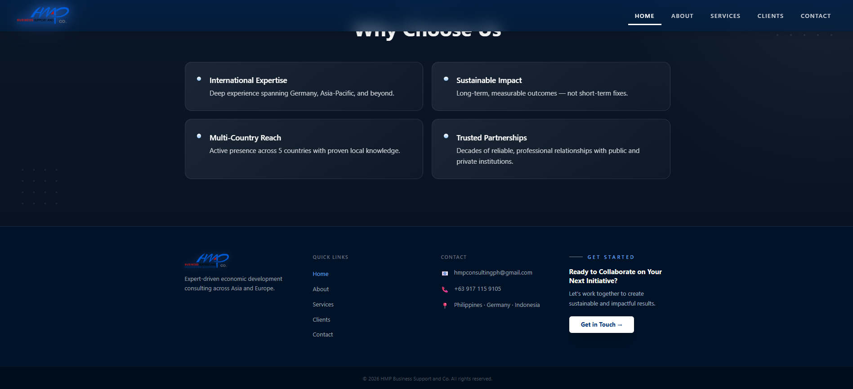
- Gradient background system implemented to support smooth visual transitions between sections

- Motion effects added at section level

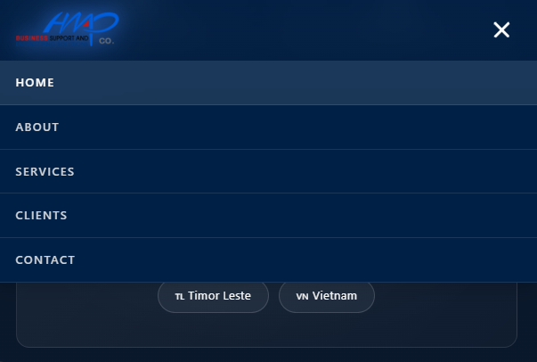

- Home Page is tested and confirmed as responsive no matter the size of the display
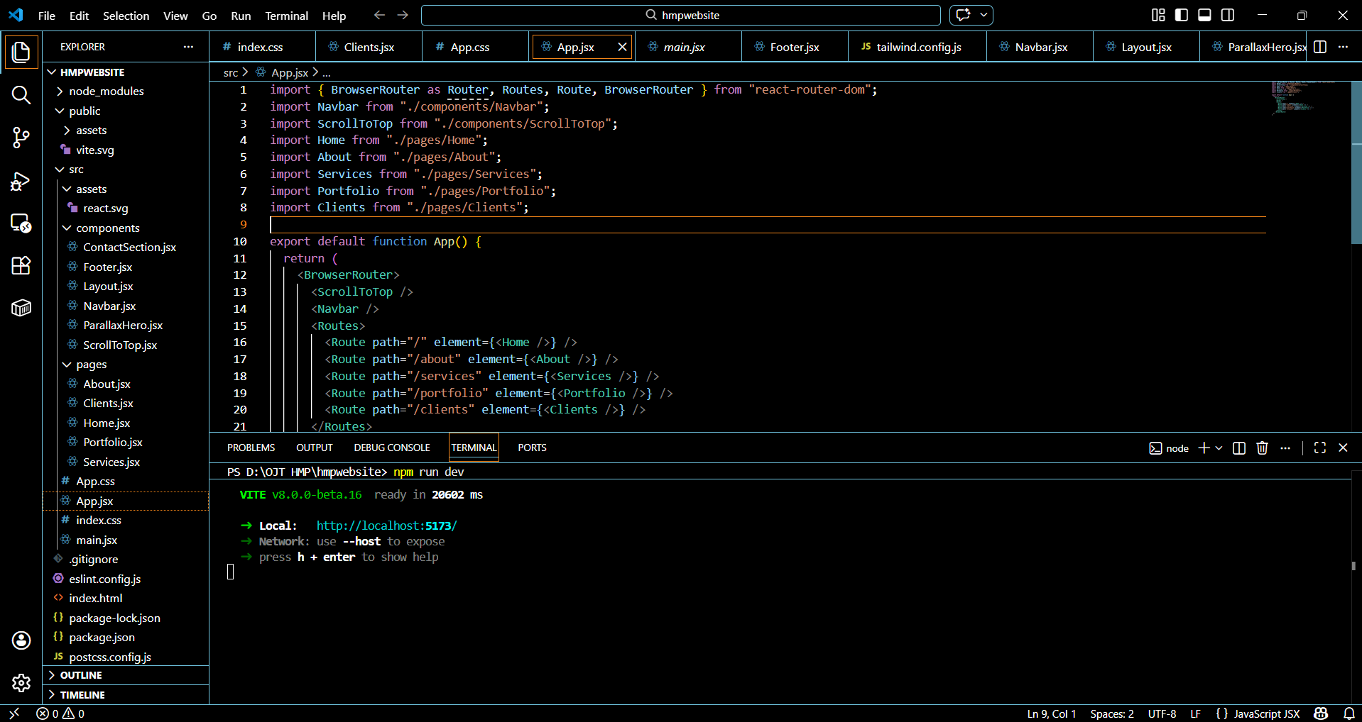
- Reusable layout containers initialized for About, Services, Clients, and Contact pages

To follow-up/notes:
- Testimonies/ratings of users/clients
- If there is a must in the content of the home page and if there are add suggestions
- If it’s okay to combine services and portfolio
- If the design is approved to proceed programming with the other pages
- If there are images that we can use for the pages
- Other pages are yet to be programmed

